UNIT 1
PN JUNCTION DIODE
1.0 INTRODUCTON
Based on the electrical conductivity all the materials in nature are classified as insulators, semiconductors, and conductors.
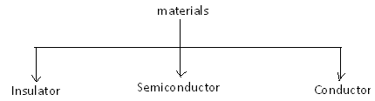
Insulator: An insulator is a material that offers a very low level (or negligible) of conductivity when voltage is applied. Eg: Paper, Mica, glass, quartz. Typical resistivity level of an insulator is of the order of 10¹⁰ to 10¹² Ω-cm. The energy band structure of an insulator is shown in the fig.1.1. Band structure of a material defines the band of energy levels that an electron can occupy. Valance band is the range of electron energy where the electron remain bended too the atom and do not contribute to the electric current. Conduction bend is the range of electron energies higher than valance band where electrons are free to accelerate under the influence of external voltage source resulting in the flow of charge.
The energy band between the valance band and conduction band is called as forbidden band gap. It is the energy required by an electron to move from balance band to conduction band i.e. the energy required for a valance electron to become a free electron.
1 eV = 1.6 x 10⁻¹⁹ J
For an insulator, as shown in the fig.1.1 there is a large forbidden band gap of greater than 5Ev. Because of this large gap there a very few electrons in the CB and hence the conductivity of insulator is poor. Even an increase in temperature or applied electric field is insufficient to transfer electrons from VB to CB.

CB
CB
CB

o
Forbidden band gap Eo ≈6eV
Eo =≈6eV

VB
VB
VB

Insulator Semiconductor Conductor

FiG:1.1 Energy band diagrams insulator, semiconductor and conductor
Conductors: A conductor is a material which supports a generous flow of charge when a voltage is applied across its terminals. i.e. it has very high conductivity. Eg: Copper, Aluminum, Silver, Gold. The resistivity of a conductor is in the order of 10⁻⁴ and 10⁻⁶ Ω-cm. The Valance and conduction bands overlap (fig1.1) and there is no energy gap for the electrons to move from valance band to conduction band. This implies that there are free electrons in CB even at absolute zero temperature (0K). Therefore at room temperature when electric field is applied large current flows through the conductor.
Semiconductor: A semiconductor is a material that has its conductivity somewhere between the insulator and conductor. The resistivity level is in the range of 10 and 10⁴ Ω-cm. Two of the most commonly used are Silicon (Si=14 atomic no.) and germanium (Ge=32 atomic no.). Both have 4 valance electrons. The forbidden band gap is in the order of 1eV. For eg., the band gap energy for Si, Ge and GaAs is 1.21, 0.785 and 1.42 eV, respectively at absolute zero temperature (0K). At 0K and at low temperatures, the valance band electrons do not have sufficient energy to move from V to CB. Thus semiconductors act a insulators at 0K. as the temperature increases, a large number of valance electrons acquire sufficient energy to leave the VB, cross the forbidden bandgap and reach CB. These are now free electrons as they can move freely under the influence of electric field. At room temperature there are sufficient electrons in the CB and hence the semiconductor is capable of conducting some current at room temperature.
Inversely related to the conductivity of a material is its resistance to the flow of charge or current. Typical resistivity values for various materials’ are given as follows.

Insulator | Semiconductor | Conductor
10⁻⁶ Ω-cm (Cu) | 50Ω-cm (Ge) | 10¹² Ω-cm (mica)
 | 50x10³ Ω-cm (Si)
Typical resistivity values

1.0.1 Semiconductor Types
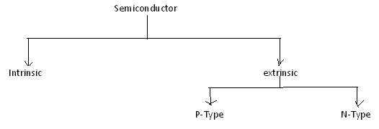

A pure form of semiconductors is called as intrinsic semiconductor. Conduction in intrinsic sc is either due to thermal excitation or crystal defects. Si and Ge are the two most important semiconductors used. Other examples include Gallium arsenide GaAs, Indium Antimonide (InSb) etc.
Let us consider the structure of Si.A Si atomic no. is 14 and it has 4 valance electrons. These 4 electrons are shared by four neighboring atoms in the crystal structure by means of covalent bond. Fig. 1.2a shows the crystal structure of Si at absolute zero temperature (0K). Hence a pure SC acts has poor conductivity (due to lack of free electrons) at low or absolute zero temperature.

Covalent bond
Valence electron
Fig. 1.2a crystal structure of Si at 0K

At room temperature some of the covalent bonds break up to thermal energy as shown in fig 1.2b. The valance electrons that jump into conduction band are called as free electrons that are available for conduction.

Free electron
Valance electron
hole

Fig. 1.2b crystal structure of Si at room temperature0K

The absence of electrons in covalent bond is represented by a small circle usually referred to as hole which is of positive charge. Even a hole serves as carrier of electricity in a manner similar to that of free electron.
The mechanism by which a hole contributes to conductivity is explained as follows:
When a bond is in complete so that a hole exists, it is relatively easy for a valance electron in the neighboring atom to leave its covalent bond to fill this hole. An electron moving from a bond to fill a hole moves in a direction opposite to that of the electron. This hole, in its new position may now be filled by an electron from another covalent bond and the hole will correspondingly move one more step in the direction opposite to the motion of electron. Here we have a mechanism for conduction of electricity which does not involve free electrons. This phenomenon is illustrated in fig1.3

Electron movement
Hole movement

Fig. 1.3a

Fig. 1.3b

Fig. 1.3c

Fig 1.3a show that there is a hole at ion 6.Imagine that an electron from ion 5 moves into the hole at ion 6 so that the configuration of 1.3b results. If we compare both fig1.3a &fig 1.3b, it appears as if the hole has moved towards the left from ion6 to ion 5. Further if we compare fig 1.3b and fig 1.3c, the hole moves from ion5 to ion 4. This discussion indicates the motion of hole is in a direction opposite to that of motion of electron. Hence we consider holes as physical entities whose movement constitutes flow of current.
In a pure semiconductor, the number of holes is equal to the number of free electrons.
1.0.2 EXTRINSIC SEMICONDUCTOR:
Intrinsic semiconductor has very limited applications as they conduct very small amounts of current at room temperature. The current conduction capability of intrinsic semiconductor can be increased significantly by adding a small amounts impurity to the intrinsic semiconductor. By adding impurities it becomes impure or extrinsic semiconductor. This process of adding impurities is called as doping. The amount of impurity added is 1 part in 10⁶ atoms.
N type semiconductor: If the added impurity is a pentavalent atom then the resultant semiconductor is called N-type semiconductor. Examples of pentavalent impurities are Phosphorus, Arsenic, Bismuth, Antimony etc.
A pentavalent impurity has five valance electrons. Fig 1.3a shows the crystal structure of N-type semiconductor material where four out of five valance electrons of the impurity atom(antimony) forms covalent bond with the four intrinsic semiconductor atoms. The fifth electron is loosely bound to the impurity atom. This loosely bound electron can be easily

Fifth valance electron of SB
CB
E_{c} B
E_{d} B
E_{v} B
Donor energy level
VB

Fig. 1.3a crystal structure of N type SC
Fig. 1.3bEnergy band diagram of N type SC

excited from the valance band to the conduction band by the application of electric field or increasing the thermal energy. The energy required to detach the fifth electron form the impurity atom is very small of the order of 0.01ev for Ge and 0.05 eV for Si.
The effect of doping creates a discrete energy level called donor energy level in the forbidden band gap with energy level E_{d} slightly less than the conduction band (fig 1.3b). The difference between the energy levels of the conducting band and the donor energy level is the energy required to free the fifth valance electron (0.01 eV for Ge and 0.05 eV for Si). At room temperature almost all the fifth electrons from the donor impurity atom are raised to conduction band and hence the number of electrons in the conduction band increases significantly. Thus every antimony atom contributes to one conduction electron without creating a hole.
In the N-type sc the no. of electrons increases and the no. of holes decreases compared to those available in an intrinsic sc. The reason for decrease in the no. of holes is that the larger no. of electrons present increases the recombination of electrons with holes. Thus current in N type sc is dominated by electrons which are referred to as majority carriers. Holes are the minority carriers in N type sc
P type semiconductor: If the added impurity is a trivalent atom then the resultant semiconductor is called P-type semiconductor. Examples of trivalent impurities are Boron, Gallium , indium etc.
The crystal structure of p type sc is shown in the fig1.3c. The three valance electrons of the impurity (boon) forms three covalent bonds with the neighboring atoms and a vacancy exists in the fourth bond giving rise to the holes. The hole is ready to accept an electron from the neighboring atoms. Each trivalent atom contributes to one hole generation and thus introduces a large no. of holes in the valance band. At the same time the no. electrons are decreased compared to those available in intrinsic sc because of increased recombination due to creation of additional holes.

hole

Fig. 1.3c crystal structure of P type sc

Thus in P type sc , holes are majority carriers and electrons are minority carriers. Since each trivalent impurity atoms are capable accepting an electron, these are called as acceptor atoms. The following fig 1.3d shows the pictorial representation of P type sc

hole (majority carrier)
Electron (minority carrier)
Acceptor atoms

Fig. 1.3d crystal structure of P type sc

- The conductivity of N type sc is greater than that of P type sc as the mobility of electron is greater than that of hole.
- For the same level of doping in N type sc and P type sc, the conductivity of an Ntype sc is around twice that of a P type sc
1.0.3 CONDUCTIVITY OF SEMICONDUCTOR:
In a pure sc, the no. of holes is equal to the no. of electrons. Thermal agitation continue to produce new electron- hole pairs and the electron hole pairs disappear because of recombination. with each electron hole pair created , two charge carrying particles are formed . One is negative which is a free electron with mobility µ_{n} . The other is a positive i.e., hole with mobility µ_{p} . The electrons and hole move in opppsitte direction in a an electric field E, but since they are of opposite sign, the current due to each is in the same direction. Hence the total current density J within the intrinsic sc is given by
J = J_{n} + J_{p}
=q n µ_{n} E + q p µ_{p} E
= (n µ_{n} + p µ_{p})qE
=σ E
Where n=no. of electrons / unit volume i.e., concentration of free electrons
P= no. of holes / unit volume i.e., concentration of holes
E=applied electric field strength, V/m
q= charge of electron or hole I n Coulombs
Hence, σ is the conductivity of sc which is equal to (n µ_{n} + p µ_{p})q. he resistivity of sc is reciprocal of conductivity.
Ρ = 1/ σ
It is evident from the above equation that current density with in a sc is directly proportional to applied electric field E.
For pure sc, n=p= n_{i} where n_{i} = intrinsic concentration. The value of n_{i} is given by
n_{i}²=AT³ exp (-E_{GO}/KT)
therefore, J= n_{i} ( µ_{n} + µ_{p}) q E
Hence conductivity in intrinsic sc is σi= n_{i} ( µ_{n} + µ_{p}) q
Intrinsic conductivity increases at the rate of 5% per º C for Ge and 7% per º C for Si.

Conductivity in extrinsic sc (N Type and P Type):
The conductivity of intrinsic sc is given by σi= n_{i} ( µ_{n} + µ_{p}) q = (n µ_{n} + p µ_{p})q
For N type , n>>p
Therefore σ= q n µ_{n}
For P type ,p>>n
Therefore σ= q p µ_{p}
1.0.4 FERMI LEVEL:
1.0.5 CHARGE DENSITIES IN P TYPE AND N TYPE SEMICONDUCTOR:
Mass Action Law:
Under thermal equilibrium for any semiconductor, the product of the no. of holes and the concentration of electrons is constant and is independent of amount of donor and acceptor impurity doping.
n.p= n_{i}²
where n= eleetron concentration
p = hole concentration
n_{i}²= intrinsic concentration
Hence in N type sc , as the no. of electrons increase the no. of holes decreases. Similarly in P type as the no. of holes increases the no. of electrons decreases. Thus the product is constant and is equal to n_{i}² in case of intrinsic as well as extrinsic sc.
The law of mass action has given the relationship between free electrons concentration and hole concentration. These concentrations are further related by the law of electrical neutrality as explained below.
Law of electrical neutrality:
Sc materials are electrically neutral. According to the law of electrical neutrality, in an electrically neutral material, the magnitude of positive charge concentration is equal to tat of negative charge concentration. Let us consider a sc that has N_{D} donor atoms per cubic centimeter and N_{A} acceptor atoms per cubic centimeter i.e., the concentration of donor and acceptor atoms are N_{D} and N_{A} respectively. Therefore N_{D} positively charged ions per cubic centimeter are contributed by donor atoms and N_{A} negatively charged ions per cubic centimeter are contributed by the acceptor atoms. Let n, p is concentration of free electrons and holes respectively. Then according to the law of neutrality
N_{D} + p =N_{A} + n …………………………………eq 1.1
For N type sc, N_{A} =0 and n>>p. Therefore N_{D} ≈ n ………………………………….eq 1.2
Hence for N type sc the free electron concentration is approximately equal to the concentration of donor atoms. In later applications since some confusion may arise as to which type of sc is under consideration a the given moment, the subscript n or p is added for Ntype or P type respectively. Hence eq1.2 becomes N_{D} ≈ n_{n}
Therefore current density in N type sc is J = N_{D} µ_{n} q E
And conductivity σ= N_{D} µ_{n} q
For P type sc, N_{D} = 0 and p>>n. Therefore N_{A} ≈ p
Or N_{A} ≈ p_{p}
Hence for P type sc the hole concentration is approximately equal to the concentration of acceptor atoms.
Therefore current density in N type sc is J = N_{A} µ_{p} q E
And conductivity σ= N_{A} µ_{p} q
Mass action law for N type, n_{n} p_{n}= n_{i}²
p_{n}= n_{i}²/ N_{D} since (n_{n}≈ N_{D})
Mass action law for P type, n_{p} p_{p}= n_{i}²
n_{p}= n_{i}²/ N_{A} since (p_{p}≈ N_{A})
1.1 QUANTITATIVE THEORY OF PN JUNCTION DIODE:
1.1.1 PN JUNCTION WITH NO APPLIED VOLTAGE OR OPEN CIRCUIT CONDITION:
In a piece of sc, if one half is doped by p type impurity and the other half is doped by n type impurity, a PN junction is formed. The plane dividing the two halves or zones is called PN junction. As shown in the fig the n type material has high concentration of free electrons, while p type material has high concentration of holes. Therefore at the junction there is a tendency of free electrons to diffuse over to the P side and the holes to the N side. This process is called 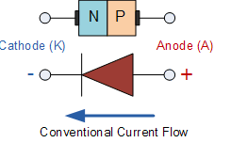
diffusion. As the free electrons move across the junction from N type to P type, the donor atoms become positively charged. Hence a positive charge is built on the N-side of the junction. The free electrons that cross the junction uncover the negative acceptor ions by filing the holes. Therefore a negative charge is developed on the p –side of the junction..This net negative charge on the p side prevents further diffusion of electrons into the p side. Similarly the net positive charge on the N side repels the hole crossing from p side to N side. Thus a barrier sis set up near the junction which prevents the further movement of charge carriers i.e. electrons and holes. As a consequence of induced electric field across the depletion layer, an electrostatic potential difference is established between P and N regions, which are called the potential barrier, junction barrier, diffusion potential or contact potential, Vo. The magnitude of the contact potential Vo varies with doping levels and temperature. Vo is 0.3V for Ge and 0.72 V for Si.
The electrostatic field across the junction caused by the positively charged N-Type region tends to drive the holes away from the junction and negatively charged p type regions tend to drive the electrons away from the junction. The majority holes diffusing out of the P region leave behind negatively charged acceptor atoms bound to the lattice, thus exposing a negatives pace charge in a previously neutral region. Similarly electrons diffusing from the N region expose positively ionized donor atoms and a double space charge builds up at the junction as shown in the fig. 1.7

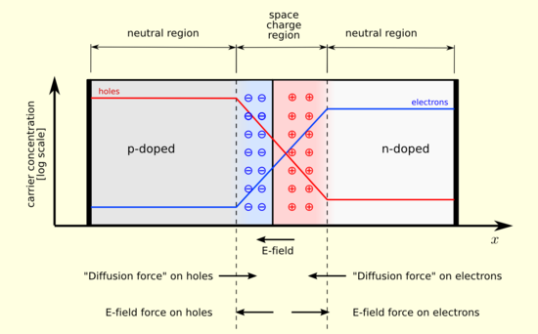
It is noticed that the space charge layers are of opposite sign to the majority carriers diffusing into them, which tends to reduce the diffusion rate. Thus the double space of the layer causes an electric field to be set up across the junction directed from N to P regions, which is in such a direction to inhibit the diffusion of majority electrons and holes as illustrated in fig 1.7. The shape of the charge density, ρ, depends upon how diode id doped. Thus the junction region is depleted of mobile charge carriers. Hence it is called depletion layer, space region, and transition region. The depletion region is of the order of 0.5µm thick. There are no mobile carriers in this narrow depletion region. Hence no current flows across the junction and the system is in equilibrium. To the left of this depletion layer, the carrier concentration is p= N_{A} and to its right it is n= N_{D}.
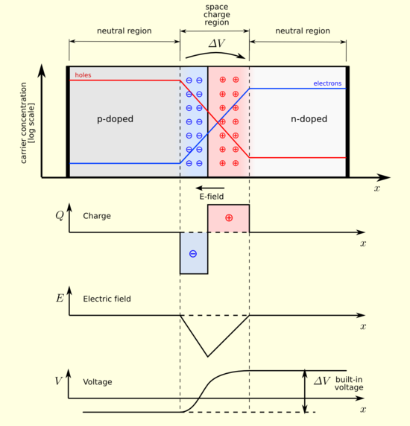

1.1.2 FORWARD BIASED JUNCTION DIODE
When a diode is connected in a Forward Bias condition, a negative voltage is applied to the N-type material and a positive voltage is applied to the P-type material. If this external voltage becomes greater than the value of the potential barrier, approx. 0.7 volts for silicon and 0.3 volts for germanium, the potential barriers opposition will be overcome and current will start to flow. This is because the negative voltage pushes or repels electrons towards the junction giving them the energy to cross over and combine with the holes being pushed in the opposite direction towards the junction by the positive voltage. This results in a characteristics curve of zero current flowing up to this voltage point, called the "knee" on the static curves and then a high current flow through the diode with little increase in the external voltage as shown below.

Forward Characteristics Curve for a Junction Diode
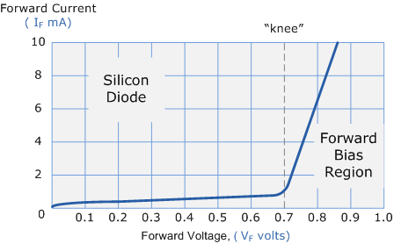
The application of a forward biasing voltage on the junction diode results in the depletion layer becoming very thin and narrow which represents a low impedance path through the junction thereby allowing high currents to flow. The point at which this sudden increase in current takes place is represented on the static I-V characteristics curve above as the "knee" point.

Forward Biased Junction Diode showing a Reduction in the Depletion Layer
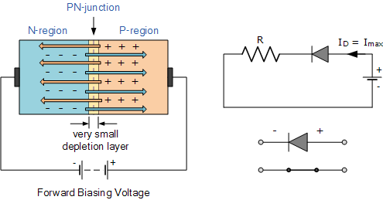
This condition represents the low resistance path through the PN junction allowing very large currents to flow through the diode with only a small increase in bias voltage. The actual potential difference across the junction or diode is kept constant by the action of the depletion layer at approximately 0.3v for germanium and approximately 0.7v for silicon junction diodes. Since the diode can conduct "infinite" current above this knee point as it effectively becomes a short circuit, therefore resistors are used in series with the diode to limit its current flow. Exceeding its maximum forward current specification causes the device to dissipate more power in the form of heat than it was designed for resulting in a very quick failure of the device.
1.1.2 PN JUNCTION UNDER REVERSE BIAS CONDITION:
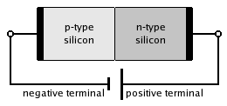
A silicon p–n junction in reverse bias.

Reverse Biased Junction Diode
When a diode is connected in a Reverse Bias condition, a positive voltage is applied to the N-type material and a negative voltage is applied to the P-type material. The positive voltage applied to the N-type material attracts electrons towards the positive electrode and away from the junction, while the holes in the P-type end are also attracted away from the junction towards the negative electrode. The net result is that the depletion layer grows wider due to a lack of electrons and holes and presents a high impedance path, almost an insulator. The result is that a high potential barrier is created thus preventing current from flowing through the semiconductor material.

Reverse Biased Junction Diode showing an Increase in the Depletion Layer
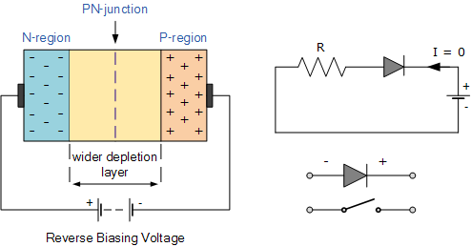
This condition represents a high resistance value to the PN junction and practically zero current flows through the junction diode with an increase in bias voltage. However, a very small leakage current does flow through the junction which can be measured in microamperes, (μA). One final point, if the reverse bias voltage Vr applied to the diode is increased to a sufficiently high enough value, it will cause the PN junction to overheat and fail due to the avalanche effect around the junction. This may cause the diode to become shorted and will result in the flow of maximum circuit current, and this shown as a step downward slope in the reverse static characteristics curve below.

Reverse Characteristics Curve for a Junction Diode
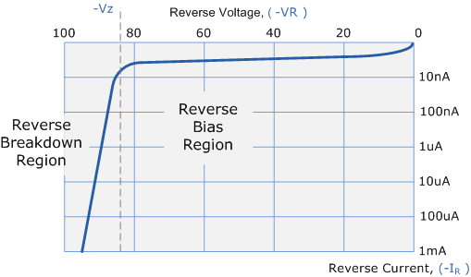
Sometimes this avalanche effect has practical applications in voltage stabilising circuits where a series limiting resistor is used with the diode to limit this reverse breakdown current to a preset maximum value thereby producing a fixed voltage output across the diode. These types of diodes are commonly known as Zener Diodes and are discussed in a later tutorial.
1.2 VI CHARACTERISTICS AND THEIR TEMPERATURE DEPENDENCE: Diode terminal characteristics equation for diode junction current:
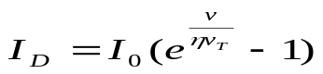
Where VT = kT/q;
VD_ diode terminal voltage, Volts
Io _ temperature-dependent saturation current, µA
T _ absolute temperature of p-n junction, K
k _ Boltzmann’s constant 1.38x 10 -23J/K)
q _ electron charge 1.6x10-19 C
= empirical constant, 1 for Ge and 2 for Si
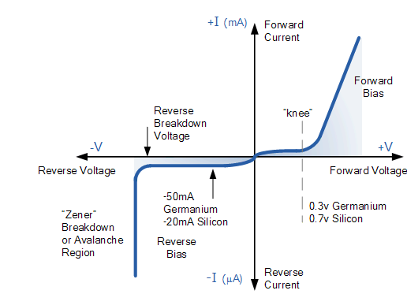
Temperature Effects on Diode
Temperature can have a marked effect on the characteristics of a silicon semiconductor diode as shown in Fig. 1.24. It has been found experimentally that the reverse saturation current Io will just about double in magnitude for every 10°C increase in temperature.
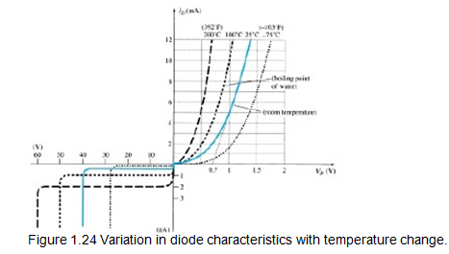

It is not uncommon for a germanium diode with an Io in the order of 1 or 2 A at 25°C to have a leakage current of 100 A _ 0.1 mA at a temperature of 100°C. Typical values of Io for silicon are much lower than that of germanium for similar power and current levels. The result is that even at high temperatures the levels of Io for silicon diodes do not reach the same high levels obtained.for germanium—a very important reason that silicon devices enjoy a significantly higher level of development and utilization in design. Fundamentally, the open-circuit equivalent in the reverse bias region is better realized at any temperature with silicon than with germanium. The increasing levels of Io with temperature account for the lower levels of threshold voltage, as shown in Fig. 1.24. Simply increase the level of Io in and not rise in diode current. Of course, the level of TK also will be increase, but the increasing level of Io will overpower the smaller percent change in TK. As the temperature increases the forward characteristics are actually becoming more “ideal,”
1.3 IDEAL VERSUS PRACTICAL RESISTANCE LEVELS
DC or Static Resistance
The application of a dc voltage to a circuit containing a semiconductor diode will result in an operating point on the characteristic curve that will not change with time. The resistance of the diode at the operating point can be found simply by finding the corresponding levels of VD and ID as shown in Fig. 1.25 and applying the following Equation:
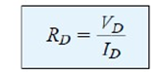

The dc resistance levels at the knee and below will be greater than the resistance levels obtained for the vertical rise section of the characteristics. The resistance levels in the reverse-bias region will naturally be quite high. Since ohmmeters typically employ a relatively constant-current source, the resistance determined will be at a preset current level (typically, a few mill amperes).

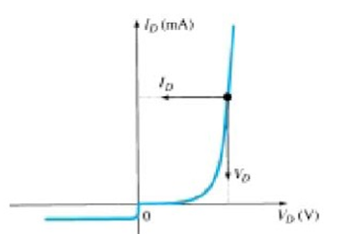
Figure 1.25 determining the dc resistance of a diode at a particular operating point.

AC or Dynamic Resistance
It is obvious from Eq. 1.5 that the dc resistance of a diode is independent of the shape of the characteristic in the region surrounding the point of interest. If a sinusoidal rather than dc input is applied, the situation will change completely. The varying input will move the instantaneous operating point up and down a region of the characteristics and thus defines a specific change in current and voltage as shown in Fig. 1.27. With no applied varying signal, the point of operation would be the Q-point appearing on Fig. 1.27 determined by the applied dc levels. The designation Q-point is derived from the word quiescent, which means “still or unvarying.” A straight-line drawn tangent to the curve through the Q-point as shown in Fig. 1.28 will define a particular change in voltage and current that can be used to determine the ac or dynamic resistance for this region of the diode characteristics. In equation form,
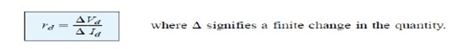
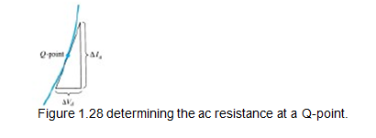
1.4 DIODE EQUIVALENT CIRCUITS
An equivalent circuit is a combination of elements properly chosen to best represent the actual terminal characteristics of a device, system, or such in a particular operating region. In other words, once the equivalent circuit is defined, the device symbol can be removed from a schematic and the equivalent circuit inserted in its place without severely affecting the actual behaviour of the system. The result is often a network that can be solved using traditional circuit analysis techniques.

Piecewise-Linear Equivalent Circuit
One technique for obtaining an equivalent circuit for a diode is to approximate the characteristics of the device by straight-line segments, as shown in Fig. 1.31. The resulting equivalent circuit is naturally called the piecewise-linear equivalent circuit. It should be obvious from Fig. 1.31 that the straight-line segments do not result in an exact duplication of the actual characteristics, especially in the knee region. However, the resulting segments are sufficiently close to the actual curve to establish an equivalent circuit that will provide an excellent first approximation to the actual behaviour of the device. The ideal diode is included to establish that there is only one direction of conduction through the device, and a reverse-bias condition will result in the open- circuit state for the device. Since a silicon semiconductor, diode does not reach the conduction state until VD reaches 0.7 V with a forward bias (as shown in Fig. 1.31), a battery VT opposing the conduction direction must appear in the equivalent circuit as shown in Fig. 1.32. The battery simply specifies that the voltage across the device must be greater than the threshold battery voltage before conduction through the device in the direction dictated by the ideal diode can be established. When conduction is established, the resistance of the diode will be the specified value of rav.
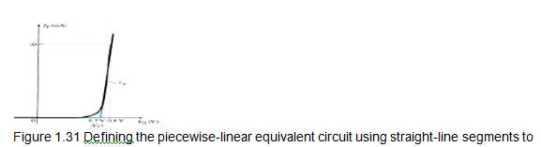

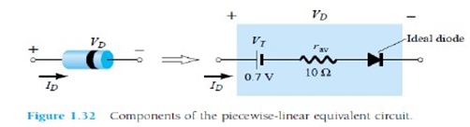
The approximate level of rav can usually be determined from a specified operating point on the specification sheet. For instance, for a silicon semiconductor diode, if IF _ 10 mA (a forward conduction current for the diode) at VD _ 0.8 V, we know for silicon that a shift of 0.7 V is required before the characteristics rise.

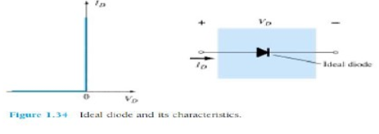

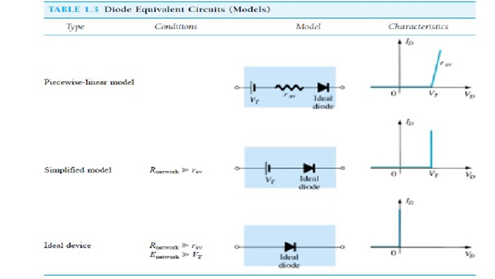
Fig 1.7d VI characteristics of ideal diode
1.5 TRANSITION AND DIFFUSION CAPACITANCE
Electronic devices are inherently sensitive to very high frequencies. Most shunt capacitive effects that can be ignored at lower frequencies because the reactance XC=1/2πfC is very large (open-circuit equivalent). This, however, cannot be ignored at very high frequencies. XC will become sufficiently small due to the high value of f to introduce a low-reactance “shorting” path. In the p-n semiconductor diode, there are two capacitive effects to be considered. In the reverse-bias region we have the transition- or depletion region capacitance (CT), while in the forward-bias region we have the diffusion (CD) or storage capacitance. Recall that the basic equation for the capacitance of a parallel-plate capacitor is defined by C=€A/d, where € is the permittivity of the dielectric (insulator) between the plates of area A separated by a distance d. In the reverse-, bias region there is a depletion region (free of carriers) that behaves essentially like an insulator between the layers of opposite charge. Since the depletion width (d) will increase with increased reverse-bias potential, the resulting transition capacitance will decrease. The fact that the capacitance is dependent on the applied reverse-bias potential has application in a number of electronic systems. Although the effect described above will also be present in the forward-bias region, it is over shadowed by a capacitance effect directly dependent on the rate at which charge is injected into the regions just outside the depletion region. The capacitive effects described above are represented by a capacitor in parallel with the ideal diode, as shown in Fig. 1.38. For low- or mid-frequency applications (except in the power area), however, the capacitor is normally not included in the diode symbol.
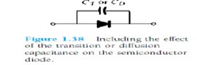
Diode capacitances: The diode exhibits two types of capacitances transition capacitance and diffusion capacitance.
. Transition capacitance: The capacitance which appears between positive ion layer in n-region and negative ion layer in p-region.
· Diffusion capacitance: This capacitance originates due to diffusion of charge carriers in the opposite regions.
The transition capacitance is very small as compared to the diffusion capacitance.
In reverse bias transition, the capacitance is the dominant and is given by:
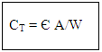where C_{T} - transition capacitance
A - diode cross sectional area
W - depletion region width
In forward bias, the diffusion capacitance is the dominant and is given by:
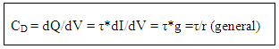where C_{D} - diffusion capacitance
dQ - change in charge stored in depletion region
V - change in applied voltage
- time interval for change in voltage
g - diode conductance
r - diode resistance
The diffusion capacitance at low frequencies is given by the formula:
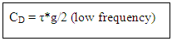The diffusion capacitance at high frequencies is inversely proportional to the frequency and is given by the formula:

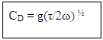Note: The variation of diffusion capacitance with applied voltage is used in the design of varactor.
1.6 BREAK DOWN MECHANISMS
When an ordinary P-N junction diode is reverse biased, normally only very small reverse saturation current flows. This current is due to movement of minority carriers. It is almost independent of the voltage applied. However, if the reverse bias is increased, a point is reached when the junction breaks down and the reverse current increases abruptly. This current could be large enough to destroy the junction. If the reverse current is limited by means of a suitable series resistor, the power dissipation at the junction will not be excessive, and the device may be operated continuously in its breakdown region to its normal (reverse saturation) level. It is found that for a suitably designed diode, the breakdown voltage is very stable over a wide range of reverse currents. This quality gives the breakdown diode many useful applications as a voltage reference source.
The critical value of the voltage, at which the breakdown of a P-N junction diode occurs is called the breakdown voltage. The breakdown voltage depends on the width of the depletion region, which, in turn, depends on the doping level. The junction offers almost zero resistance at the breakdown point.
There are two mechanisms by which breakdown can occur at a reverse biased P-N junction :
- avalanche breakdown and
- Zener breakdown.
Avalanche breakdown and
The minority carriers, under reverse biased conditions, flowing through the junction acquire a kinetic energy which increases with the increase in reverse voltage. At a sufficiently high reverse voltage (say 5 V or more), the kinetic energy of minority carriers becomes so large that they knock out electrons from the covalent bonds of the semiconductor material. As a result of collision, the liberated electrons in turn liberate more electrons and the current becomes very large leading to the breakdown of the crystal structure itself. This phenomenon is called the avalanche breakdown. The breakdown region is the knee of the characteristic curve. Now the current is not controlled by the junction voltage but rather by the external circuit.
Zener breakdown
Under a very high reverse voltage, the depletion region expands and the potential barrier increases leading to a very high electric field across the junction. The electric field will break some of the covalent bonds of the semiconductor atoms leading to a large number of free minority carriers, which suddenly increase the reverse current. This is called the Zener effect. The breakdown occurs at a particular and constant value of reverse voltage called the breakdown voltage, it is found that Zener breakdown occurs at electric field intensity of about 3 x 10^7 V/m.
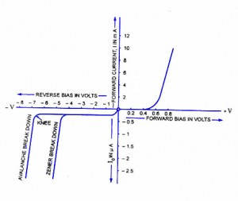
Either of the two (Zener breakdown or avalanche breakdown) may occur independently, or both of these may occur simultaneously. Diode junctions that breakdown below 5 V are caused by Zener effect. Junctions that experience breakdown above 5 V are caused by avalanche effect. Junctions that breakdown around 5 V are usually caused by combination of two effects. The Zener breakdown occurs in heavily doped junctions (P-type semiconductor moderately doped and N-type heavily doped), which produce narrow depletion layers. The avalanche breakdown occurs in lightly doped junctions, which produce wide depletion layers. With the increase in junction temperature Zener breakdown voltage is reduced while the avalanche breakdown voltage increases. The Zener diodes have a negative temperature coefficient while avalanche diodes have a positive temperature coefficient. Diodes that have breakdown voltages around 5 V have zero temperature coefficient. The breakdown phenomenon is reversible and harmless so long as the safe operating temperature is maintained.
1.7 ZENER DIODES
The Zener diode is like a general-purpose signal diode consisting of a silicon PN junction. When biased in the forward direction it behaves just like a normal signal diode passing the rated current, but as soon as a reverse voltage applied across the zener diode exceeds the rated voltage of the device, the diodes breakdown voltage V_{B} is reached at which point a process called Avalanche Breakdown occurs in the semiconductor depletion layer and a current starts to flow through the diode to limit this increase in voltage.
The current now flowing through the zener diode increases dramatically to the maximum circuit value (which is usually limited by a series resistor) and once achived this reverse saturation current remains fairly constant over a wide range of applied voltages. This breakdown voltage point, V_{B} is called the "zener voltage" for zener diodes and can range from less than one volt to hundreds of volts.
The point at which the zener voltage triggers the current to flow through the diode can be very accurately controlled (to less than 1% tolerance) in the doping stage of the diodes semiconductor construction giving the diode a specific zener breakdown voltage, (Vz) for example, 4.3V or 7.5V. This zener breakdown voltage on the I-V curve is almost a vertical straight line.

Zener Diode I-V Characteristics
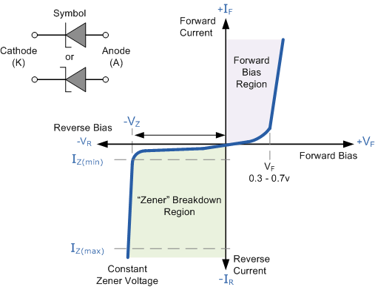
The Zener Diode is used in its "reverse bias" or reverse breakdown mode, i.e. the diodes anode connects to the negative supply. From the I-V characteristics curve above, we can see that the zener diode has a region in its reverse bias characteristics of almost a constant negative voltage regardless of the value of the current flowing through the diode and remains nearly constant even with large changes in current as long as the zener diodes current remains between the breakdown current I_{Z(min)} and the maximum current rating I_{Z(max)}.
This ability to control itself can be used to great effect to regulate or stabilise a voltage source against supply or load variations. The fact that the voltage across the diode in the breakdown region is almost constant turns out to be an important application of the zener diode as a voltage regulator. The function of a regulator is to provide a constant output voltage to a load connected in parallel with it in spite of the ripples in the supply voltage or the variation in the load current and the zener diode will continue to regulate the voltage until the diodes current falls below the minimum I_{Z(min)} value in the reverse breakdown region.

